Grace Steranko

Assignment 4.2

24 August 2022

1. CSS Validator

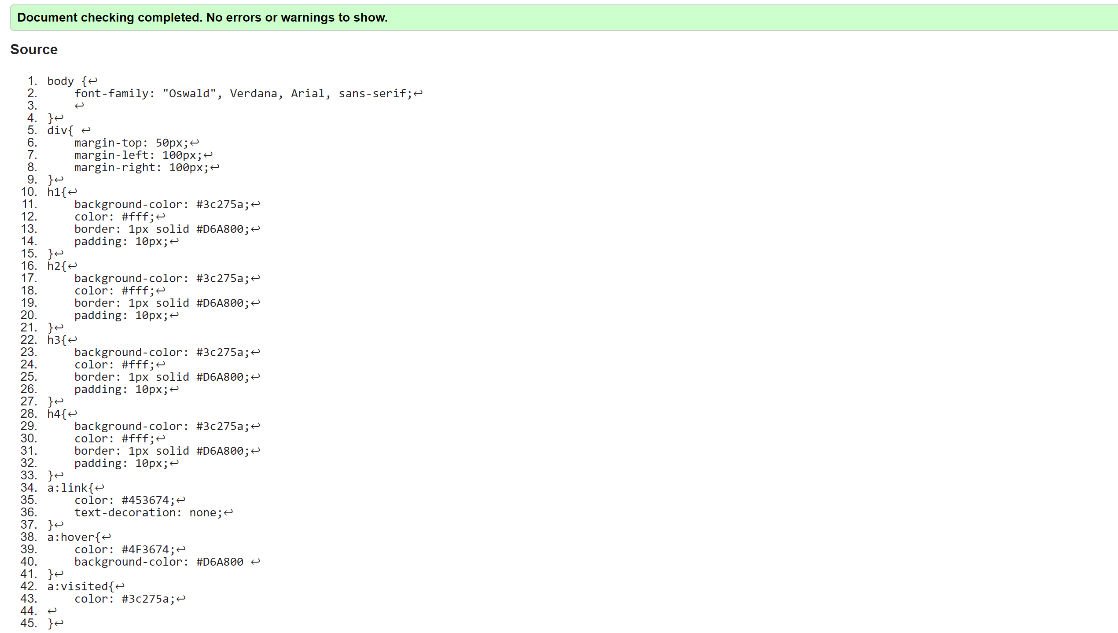

1. HTML Validator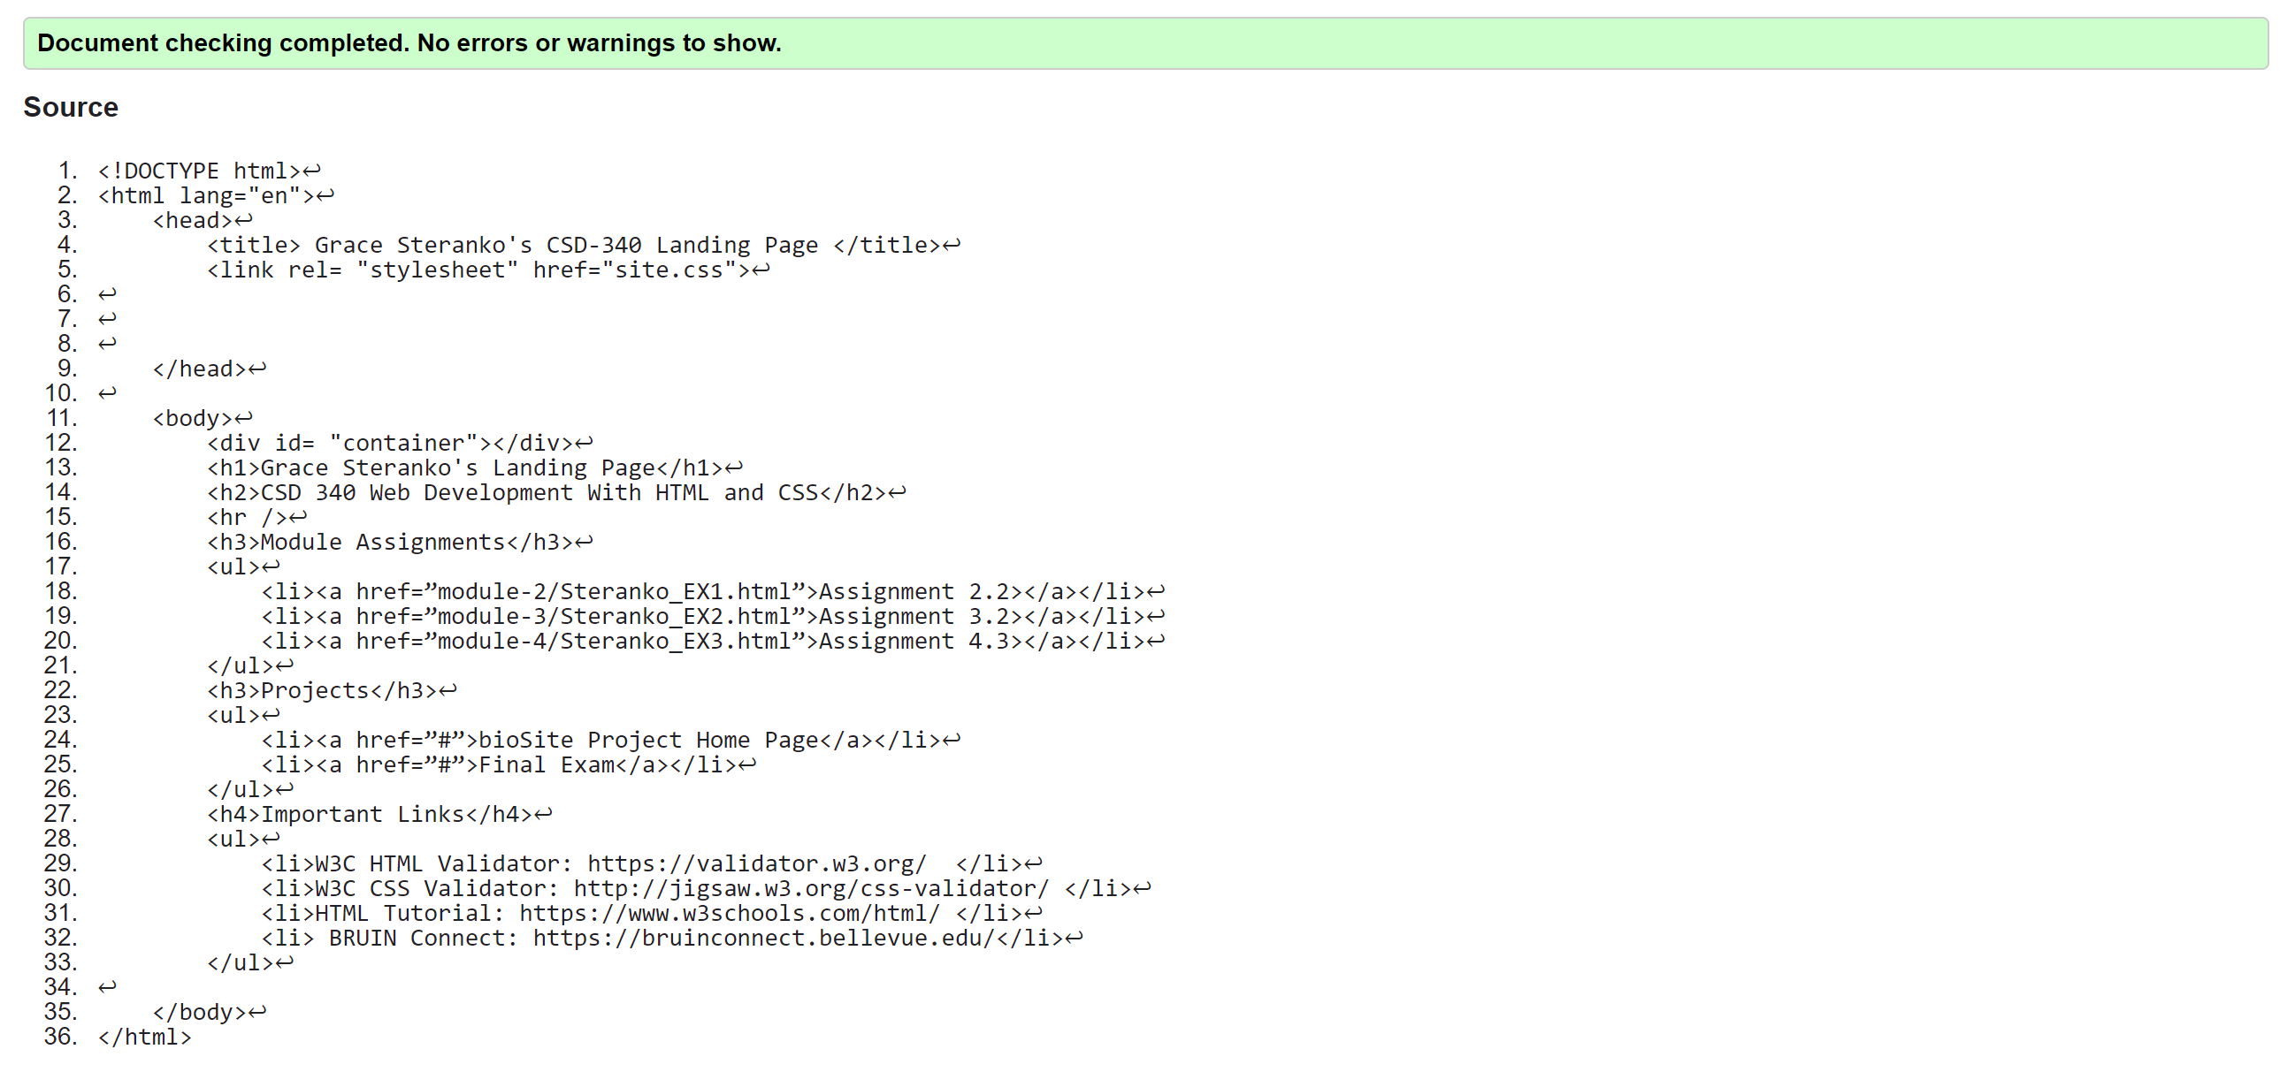
2. Landing Page

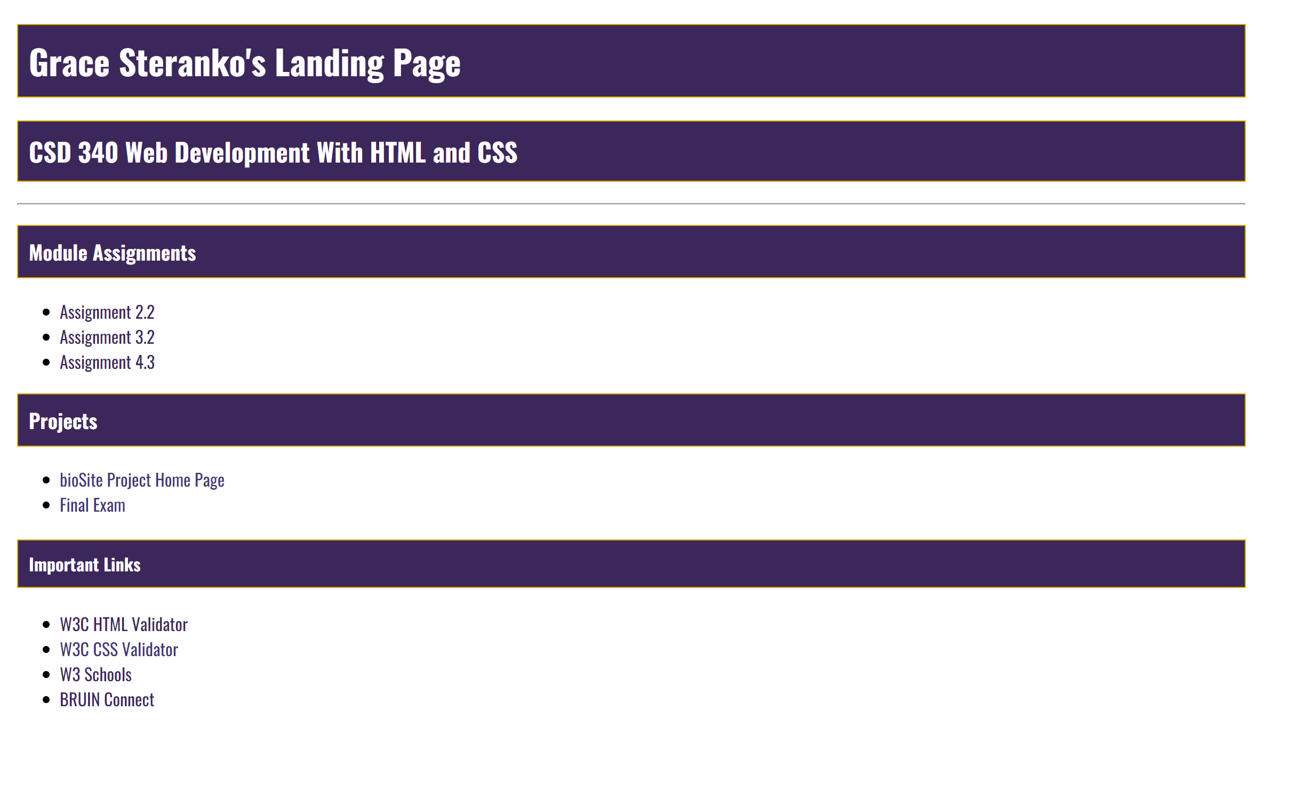

GItHub Link: <https://github.com/GRACESTER/csd-340>

GitHub Pages: <https://gracester.github.io/csd-340/>